**Introduction to Power BI desktop**

**Power BI Desktop**

Power BI Desktop is a free application you install on your local computer that lets you connect to, transform, and visualize your data. With Power BI Desktop, you can connect to multiple different sources of data, and combine them (often called modeling) into a data model. This data model lets you build visuals, and collections of visuals you can share as reports, with other people inside your organization. Most users who work on business intelligence projects use Power BI Desktop to create reports, and then use the Power BI service to share their reports with others.

* **Install Power BI Desktop and share the final screenshot of the report view page which appears when power desktop starts.**

With Power BI Desktop installed, home screen appears as report view with bank canvas after starting PBI desktop as shown in figure below.

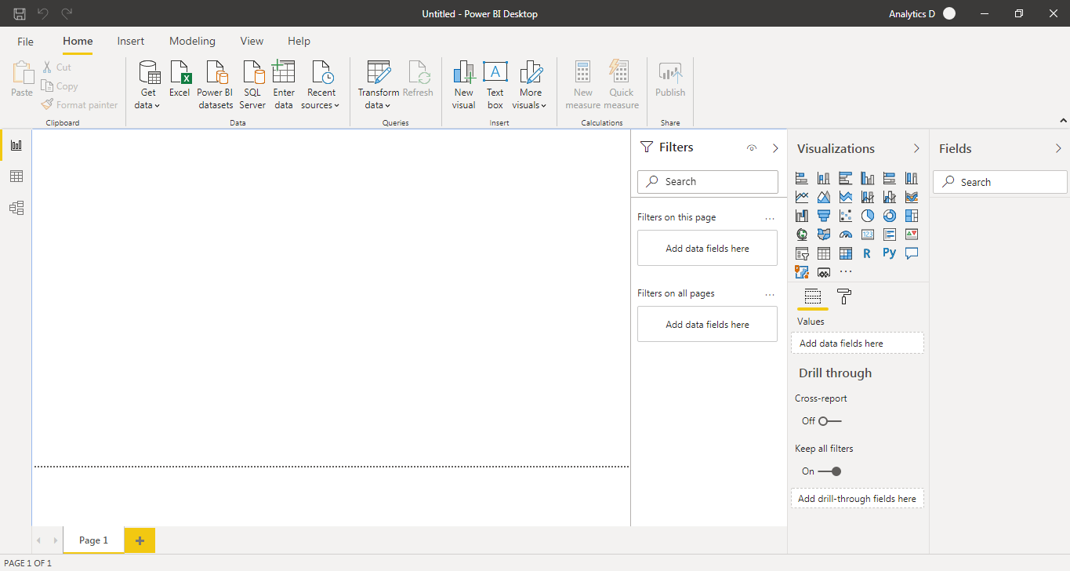

**• Prepare a document and with the following screenshot**

1. Report View
2. Data View
3. Model View
4. Power Query Editor
5. Advance Editor

**1) Report View:-**

A Power BI report is a multi-perspective view into a dataset, with visuals that represent different findings and insights from that dataset. A report can have a single visual or pages full of visuals.

It consist of visualization tools, filters, fields and a blank canvas on which we draw visualization for better and efficient interpretation of data.

Visualization tools consist of various charts and graph like bar, pie chart, scatter plot etc.



**1) Data View:-**

Data view helps you inspect, explore, and understand data in your Power BI Desktop model. It's different from how you view tables, columns, and data in Power Query Editor. With Data view, you're looking at your data after it has been loaded into the model.

We can load data with the help of get data option that is present in home ribbon. there are 3 small windows in at left side of PBI canvas first one is for report view, 2nd for data view and 3rd for model view. After loading data, our data view looks like this-

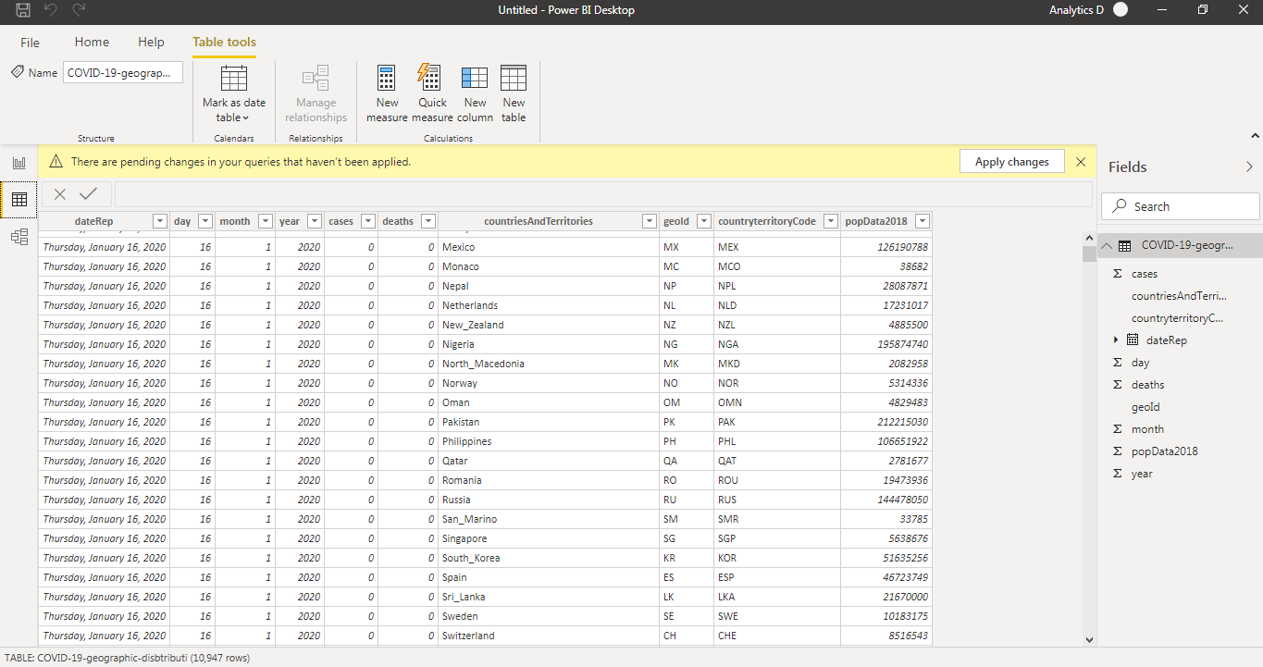

Here we can perform various operation on data as per our requirements.

**3) Model View:-**

Model view shows all of the tables, columns, and relationships in your model. This view can be especially helpful when your model has complex relationships between many tables. Select the Model icon near the side of the window to see a view of the existing model.

We can access model view by clicking on 3rd small window on left hand side.

If we have n number of tables in our dataset, model view is used to show relationship among them.

Relationship can be

* one to many
* many to many

Following screenshot shows relationship between table and their representation on PBI desktop.

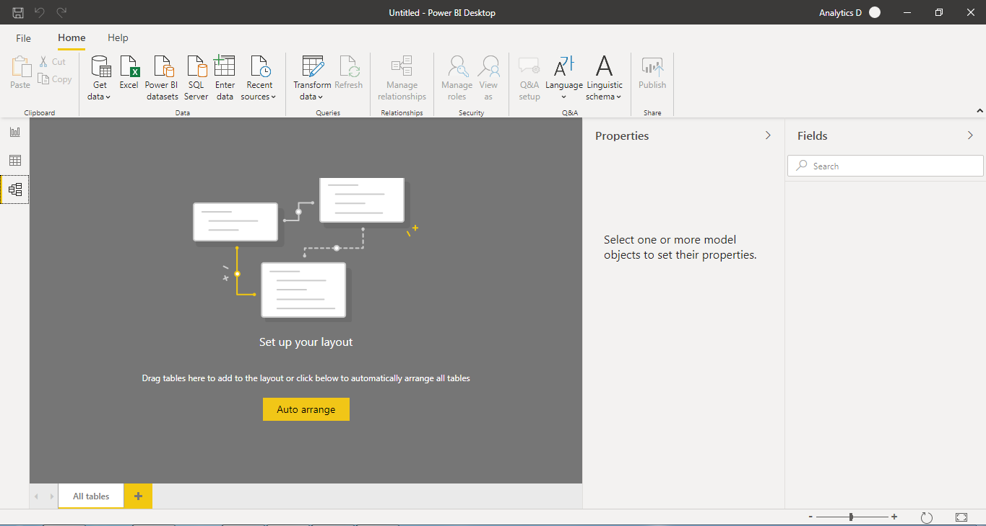

**4) Power Query Editor:-**

With **Power Query** in **Power BI** you can connect to many different data sources, transform the data into the shape you want, and quickly be ready to create reports and insights. When using Power BI Desktop, **Power Query** functionality is provided in the **Power Query Editor.**

To launch Power Query Editor, select **transform data** from the **Home** tab of Power BI Desktop. The Power Query Editor window will pop up right away.

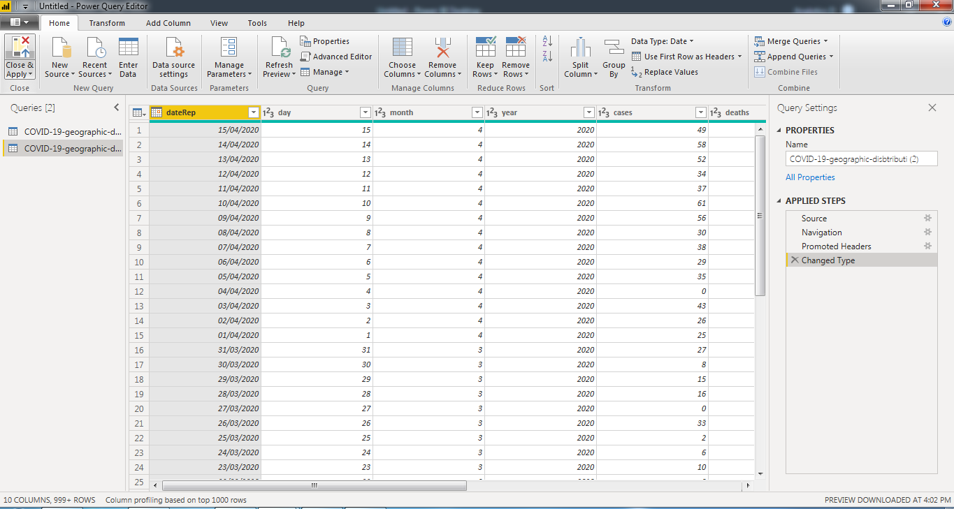

With the help of power query editor we can perform following operations-

* Connect to data
* Shape and combine data
* Group rows
* Pivot columns
* Create custom columns
* Query formulas

**5) Advance Editor:-**

The **Advanced Editor** lets you see the code that Power Query Editor is creating with each step. It also lets you create your own shaping code. To launch the advanced editor, select **View** from the ribbon, then select **Advanced Editor**. A window appears, showing the existing query code.

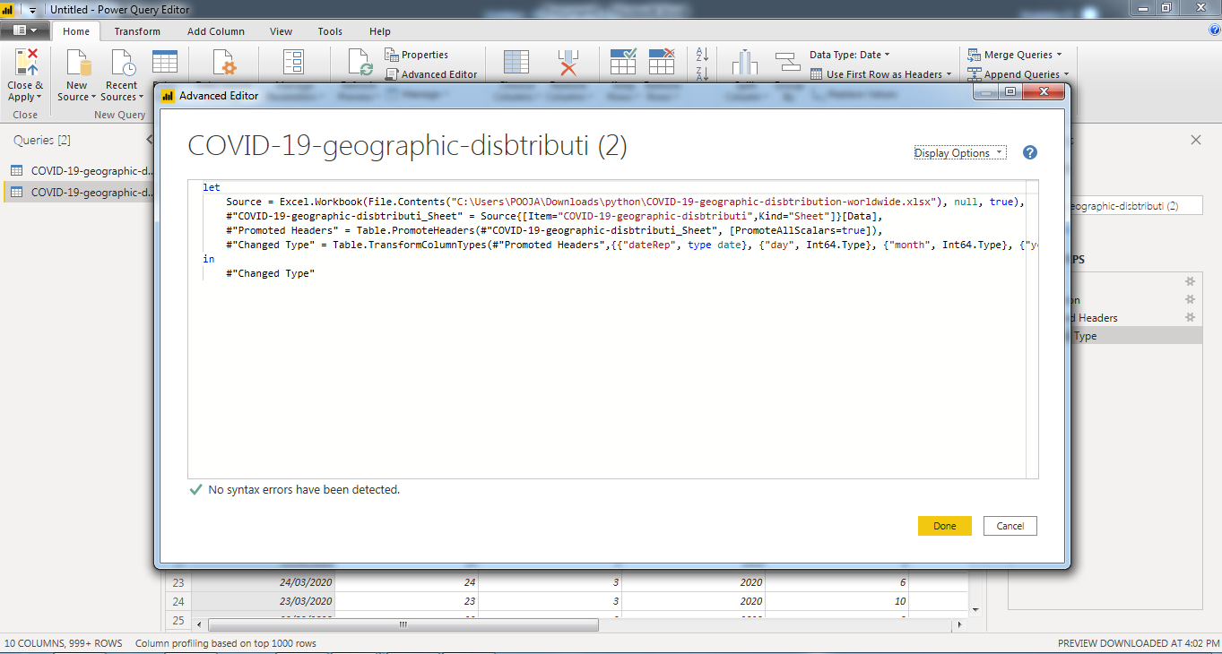

You can directly edit the code in the **Advanced Editor** window. To close the window, select the **Done** or **Cancel** button.

**Versions of Power BI**

Microsoft Power BI is a cloud-based business intelligence and analytics service that provides a full overview of your most critical data. Connecting to all of your data sources, Power BI simplifies data evaluation and sharing with scalable dashboards, interactive reports, embedded visuals and more.

**• Prepare a document with details of the following along with their price**

1)Power BI Desktop

2)Power BI Pro

3)Power BI Premium

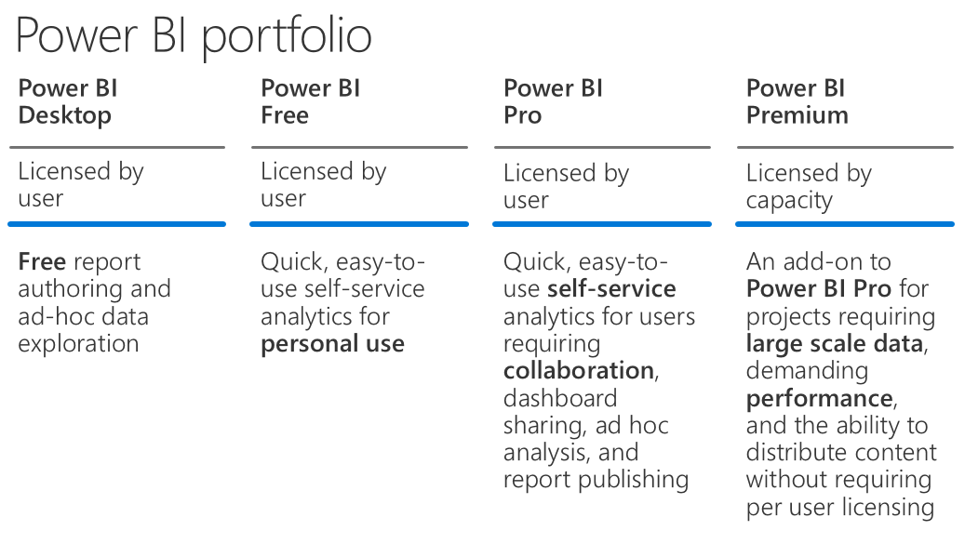

**1) Power BI Desktop**

Power BI Desktop is the free version of Power BI that you can install on your local computer as a program, and acts as a companion desktop application to the full version of Power BI. If you need to consolidate your data sources, create your own reports and conduct your own analysis or test it’s capabilities, it’s the perfect version to start with for all skill levels - whether you’re non-IT and want to make your reports more interactive, or analysts seeking richer detail, it's one of the best business analytics tools to use.

Features of Power BI desktop

* You can connect and import data from over 70 cloud-based and on-premises sources
* The same rich visualisations and filters from Power BI Pro
* Auto-detect that finds and creates data relationships between tables and formats
* Export your reports to CSV, Microsoft Excel, Microsoft PowerPoint and PDF
* Python support
* Save, upload and publish your reports to the Web and the full Power BI service
* Storage limit of 10 GB per user

Limitation of Power BI desktop

* Can’t share created reports with non-Power BI Pro users
* No App Workspaces
* No API embedding
* No email subscriptions
* No peer-to-peer-sharing
* No support to analyze in Excel within Power BI Desktop

To be very clear: All of Power BI’s basic features - cleaning and preparing data, connectors to data sources, custom reports, visualizations and exports to Microsoft apps are included in Power BI Desktop. Thus, whatever core functionality or features are available in Power BI Desktop are also standard in the higher-tier, paid versions.

**Price:-**

Power BI Desktop is a [free download](https://www.microsoft.com/en-us/download/details.aspx?id=45331) available directly from Microsoft as a MSI package, with Windows 10, Windows 7, Windows 8, Windows Server 2008 R2, Windows Server 2012 and Windows Server 2012 R2 operating systems currently supported.

**2) Power BI Pro**

Power BI Pro is the full version of Power BI, complete with the ability to use Power BI for both building dashboards and reports and unlimited viewing, sharing and consumption of your created reports (and reports shared by others) - the latter not possible with Power BI Desktop.

A breakdown of Power BI Pro’s differences against Power BI Desktop:

* Ability to embed Power BI visuals into apps (PowerApps, SharePoint, Teams, etc)
* Native integration with other Microsoft solutions (Azure Data Services)
* Share datasets, dashboards and reports with other Power BI Pro users
* Can create App Workspaces and peer-to-peer sharing

Power BI Pro is licensed by individual user. For example, if your organisation has 20 people that need to full capabilities of self-service BI to create dashboards and reports, you need 20 licenses of Power BI Pro, which gives these users full access to creation of reports and unlimited consumption (viewing) of any created content.

If you have a lot of users, Power BI Pro can obviously become quite expensive - but there’s a better option if you have more users that need to consume reports than use Power BI for creating reports, which we detail below.

**Price:-**

Pro plan costs $9.99 per user per month that is Rs. 757.57 in Indian Rupees.

**3) Power BI Premium**

Power BI Premium is the most expensive tier of Power BI currently available and very distinct from the other two versions available on the market.

On top of the features and functionality standard to all versions of the service, users of Power BI Premium get:

* Increased data capacity limits and maximum performance
* Access to one API surface
* Ability to embed Power BI visuals into apps (PowerApps, SharePoint, Teams, etc)
* Larger storage sizes for extended deployments
* Geo distribution, higher refresh rates, isolation, pin to memory, read-only replicas
* Power BI Report Server

Power BI Premium differs from the free version and Power BI pro in its licensing model, which only suits a specific size and type of organisation and business scenario. You can purchase Premium in a range of capacity sizes that offer different numbers of memory and virtual cores that can scale as your data analysis requirements change.

With Power BI Premium, you are licensing capacity for your datasets, dashboards and reports, not just licensing all users of that content. In other words, you’re not buying individual licenses, you’re buying them in bulk to allow a large number of your users to use Power BI to view reports. All of your content is stored in Premium and can then be viewed by as many users in your organisation as you want, without additional per-user costs.

**Price:-**

The Premium plan starts at $4,995 a month per dedicated cloud compute and storage resource.